Muhammad Umar Farooq
ST: 9:55, ED: 10:46
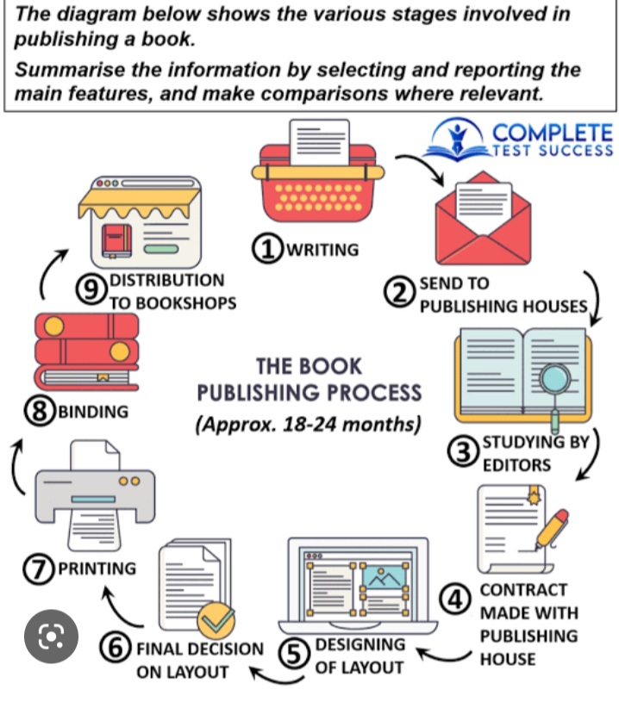
The provided diagram illustrates the multiple stages involved in the process of publishing a book.
Overall, the process begins with writing, and go through some intermediate stages like drafting, printing, binding and ends on distribution to bookshops. Meanwhile, this process took about two years.
Looking at the details, initially operation starts from the writing stage and then send to publishing house. At next, book studied by the editors. After that, the writer made a contract with publishing house which may have some legal and copywrites. Following that, this is the stage which gives a book representation according to their domain, on this point publishing house and writer collaborate design the layout of the book and the cycle then repeats to final decision on layout. In the subsequently stage, book is ready to printing and binding. As result book is distributed to bookshops and ready to rise the light of knowledge and make humanity better.

Muhammad Umar Farooq
Some people say History is one of the most important school subjects. Other people think that, in today's world, subjects like Science and Technology are more important than History. Discuss both these views and give your own opinion.

School education is the topic that provoke diverse opinion, with some advocating that the history is one of the most crucial subject to study, while other believe that, in today’s revolutionized world, science and technology have more significantly important than history. In my way of thinking, both have their own existence to make the society better.
On the one hand, history is crucial because it helps people to understand from the past experiences. Also, this subject connects the young generation with their roots, inherits the cultural and traditional values which makes a nation proud from their ancestors and a sense of individualism. In addition to that, the famous saying is, ‘past is the foundation of the future’. For instance, learning from the world wars, local fights, pandemics, and conflicts give the important lesson about the international relation and collaboration with outside the borders to rise up.
On the other hand, opponents argue that the science and technology are more critical in today’s world due to their direct impact on economy. Meanwhile, everything revolves around the technological revolution. Nonetheless, the industries have shifted on more advance machines which are carrying the embedded computers, the evolution of artificial intelligence, so that is way they need more technical and skilled workers. For instance, advancement in artificial intelligence, renewable energy, and healthcare dramatically improved due to science and technology.
To recapitulate, history opens a window for people to see in the past, but science always sparks in the present. In my opinion, this is far better to make a medicine to cure a disease rather than to have knowledge about the past. Finally, this is the tech era, so we have to move with it to survive.

